MED D - Prospective Member Mailing Removal Request During AEP

General Information
No Mail Requests
Related Documents

Description: This document provides the MED D Customer Care Representative (CCR) with consistent steps to follow for requests to be removed from mailing list.

This process is strictly for CCRs receiving calls from the Enrollment/Marketing line.

General Information

There are several reasons why a prospective beneficiary would request to be removed from the marketing materials mailing list during Annual Election Period (AEP).

Examples include:
- Death of the beneficiary.
- Prospective beneficiary does not live at the address.
- Caller is receiving marketing materials during AEP that they do not want to receive.
- Caller is not eligible for Medicare D.

Top of the Document

No Mail Requests
If a prospective beneficiary contacts Med D Customer Care requesting to be removed from the mailing list, the CCR will:

Step | Action
1 | Open the Qualtrics Survey: https://cvs.az1.qualtrics.com/SE/?SID=SV_ai4KNaWwYvq9uaF  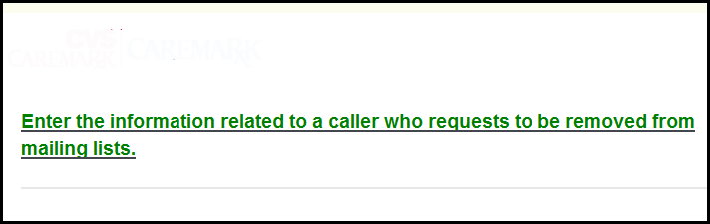
2 | Fill in the appropriate information:  - Caller First and Last Name  - Caller’s Street Address (1st and 2nd line)  - City, State and Zip Code+4  - Type of Material Received  - VDN  - CCR Info (Name, Employee ID and Location)
3 | Click arrow at the bottom right of the screen.    This report is then provided to Marketing.

Top of the Document

Related Documents
Parent SOP: CALL-0048: Medicare Part D Customer Care Call Center Requirements-CVS Caremark Part D Services, L.L.C.
Abbreviations/Definitions: Abbreviations / Definitions

Top of the Document

Not to Be Reproduced or Disclosed to Others without Prior Written Approval
ELECTRONIC DATA = OFFICIAL VERSION - PAPER COPY - INFORMATIONAL ONLY

